Medium Term Plan – I spy from the London Eye Spring 1 – 2026

 | Week 1  5.1.26 |  |  | Week 2  12.1.26 |  |  | Week 3  19.1.26 |  |  | Week 4  26.1.26 |  | Week 5  2.2.26 |  |  |  | Week 6  9.2.26
 |  |  |  |  |  |  |  |  |  |  |  | Children’s Mental Health Week
Dates | 5.1.26 INSET |  |  | Pupil Progress 12th |  |  | Set Home Challenge – London Landmark junk modelling.  21.1.26 Drama with Fiona |  |  |  |  | Number Day on Friday 6th February 2026. |  |  |  | Exhibition of home challenge  Year 1 assembly??  Feb
Phonics | Little Wandle  Autumn 1  Week 1 and 2 |  |  | Little Wandle  Autumn 1  Week 3 and 4 |  |  | Little Wandle  Autumn 1  Week 5 and asses |  |  | Little Wandle  Autumn 2  Week 1 and 2 |  | Little Wandle  Autumn  Week 3 and 4 |  |  |  | Little Wandle  Autumn 1  Week 5 and Assess
English | Monday INSET  TUESDAY  To write in the first person (I, My, We)  I got …. For Christmas.  I ate …  I went …  Wednesday  Read Paddington  Thursday  How to make a Marmalade Sandwich  First put butter the bread.  Next add the marmalade.  Finally eat the sandwich.  Friday: (STAR WRITE) |  |  | 2nd Week of Paddington  I can use a capital letter for Names of Places and People.  I can use a time opener.  I can use ‘and’ to extend a sentence.  Monday; Recap story,  Add time openers to story map; Introduce the WAGOLL  Tuesday; First Paddington went to London on a train.  Wednesday; Then he went to Tower Bridge and …  .  Thursday; Finally he went on the train back home.  Friday; STAR WRITE  Pre-Read We’re Going on a Bear Hunt. |  |  | We’re going on a bear hunt.  *I can use a question mark to demarcate a sentence starting with ‘will’ and ‘what’  They  *I can use adjectives to describe a character. (Bear)  Monday  WAGOLL.  Tuesday  First they go on a bear hunt.  Wednesday  What will they see?  They will see …  Thursday  What will they find in the cave?  They will find ….in the cave.  Adjectives to describe the bear.  Friday  STAR WRITE  Pre-Read Where’s my Teddy? |  |  | Whatever Next  I can use a variety of openers.  (He They)  Monday  WAGOLL.  Tuesday  Bear found a rocket under the stairs and went to the moon.  Wednesday  They had a picnic on the moon.  Thursday  He had a bath and went to bed.  Friday  STAR WRITE |  | Can’t you sleep little bear?  I can use a variety of time adverbs.  I can use ‘and’ to extend a sentence.  (The, They)  Monday  WAGOLL.  Tuesday  When night time came the two bears went home to the cave.  Wednesday  Soon it was time for bed. Little bear was scared of the dark.  Thursday  Later they went outside to see the bright yellow moon and twinkly stars.  Friday  STAR WRITE  Pre-Read - Whatever Next |  |  |  | Goldilocks and the 3 bears.  I can use a variety of openers.  On  When  Once upon a time  I can use a diary entry as a character.  I can use ‘and’ to extend a sentence.  Monday  WAGOLL  Tuesday  Once upon a time  there was a house in the woods where 3 bears lived and a girl came to visit.  Wednesday  Character - Goldilocks  On Thursday I went for a walk in the woods and saw a house.  I went inside and …  Character - Baby bear  When I got back from my walk I found my chair was broken and a girl in my bed.
SPaG | - Use the personal pronoun ‘I’ (when writing a personal recount)  - To write in the first person. I, My, We.  - Use adjectives to describe thoughts and feelings (diary entry as a character, informal letter)  - Use a wider variety of openers (Once Upon a Time)  - Increase use of a variety of time words (time adverbials/time adverbs) (Later, Soon, at last)  - Use a question mark to demarcate a question sentence starting with Will and What.  - Use ‘and’ to join words and to join clauses in sentences.
Spelling | o-e (home, those, woke, hope, hole)  Write in the past tense.  u-e (June, rule, rude, use, tube, tune)  ar (car, start, park, arm, garden)  ee (see, tree, green, meet, week) ea (/i:/)  (sea, dream, meat, each, read (present tense)  e-e (these, theme, complete) |  |  |  |  | er (/ɜ:/) (stressed sound) (her, term, verb, person)  er (/Ə/) (unstressed schwa sound) (better, under, summer, winter, sister)  ir (girl, bird, shirt, first, third)  ur (turn, hurt, church, burst, Thursday)  oa (boat, coat, road, coach, goal)  oe (toe, goes) |  |  |  |  |  |  | ou (out, about, mouth, around, sound)  ow (/aƱ/) (now, how, brown, down, town)  ow (/ƏƱ/) (own, blow, snow, grow, show)  ue (blue, clue, true, rescue, Tuesday)  ew (new, few, grew, flew, drew, threw
Handwriting | Numbers |  |  | Curly Caterpillars  c (adgo)  Paddington |  |  | One armed Robots  (rnbh) m  We’re going on a bear hunt |  |  | CAPITIAL LETTERS |  | CAPITAL LETTERS |  |  |  | CAPITAL LETTERS
Handwriting | LO; My letters are close together when I write a word (snuggle my letters)  LO: I fill the line with my writing.
Maths | 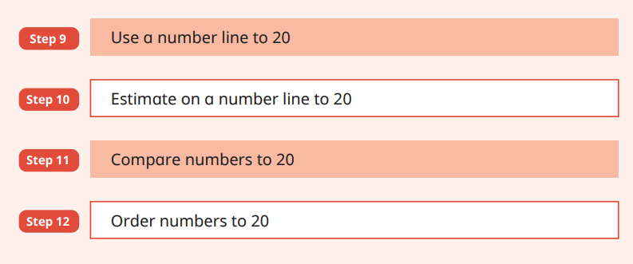  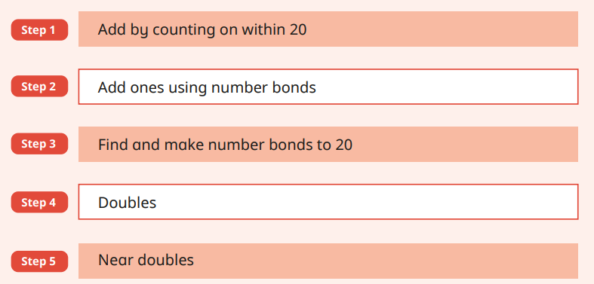  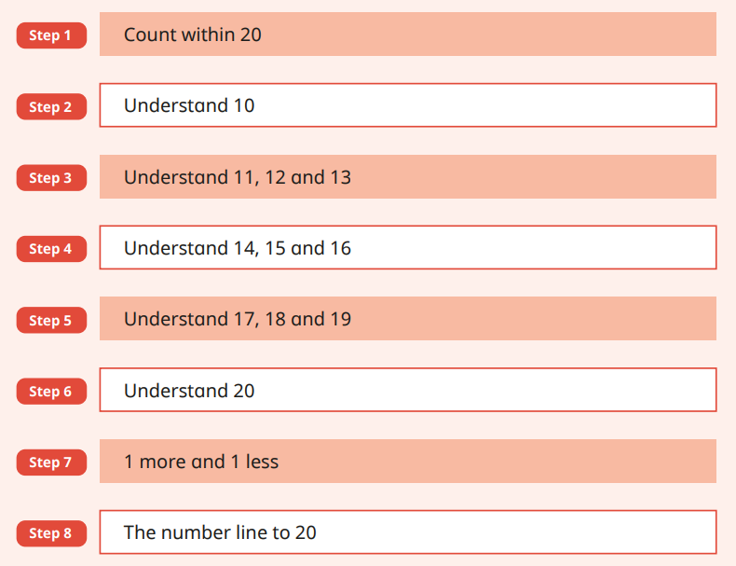  Roughly cover three a week!
NCETM | Week 10 Week 11 Week 12 Week 13 Week 14 Week 15
Science | Distinguish between an object and the material from which it is made  Identify and name a variety of everyday materials, including wood, plastic, glass, metal, water, and rock |  |  | Describe the simple physical properties of a variety of everyday materials  Compare and group together a variety of everyday materials on the basis of their simple physical properties. |  |  | Identify and name a variety of everyday materials, including wood, plastic, glass, metal, water, and rock  Describe the simple physical properties of a variety of everyday materials.  I can use sensory experiences to explore a variety of materials (Art) and make marks to represent each texture. |  |  | Observe and describe weather associated with the seasons.  WATERPROOF. 1. Sort materials into waterproof and non- waterproof (SCIENCE EXPERIMENT Fair testing) |  |  |  |  |  | Distinguish between an object and the material from which it is made  Identify and name a variety of everyday materials, including wood, plastic, glass, metal, water, and rock  Children to create key London Landmarks using a variety of materials
Geography  KPOW  What is the weather like in the UK? | Where is the UK? |  |  | What are the Four seasons? |  |  | What are the compass directions? |  |  | What is the Weather like today? |  | Is the weather the same everywhere in the UK? |  |  |  | How do people prepare for the weather?
History | *** |  |  | *** |  |  | *** |  |  | *** |  | *** |  |  |  | ***
Art  Drawing | To develop a wide range of art and design techniques in using colour, pattern, texture, line, shape, form and space  Become proficient in drawing.  Introduce words  Sketch.  Shape 2D and 3D  Shade  Sketch book ideas. |  |  | To develop a wide range of art and design techniques in using colour, pattern, texture, line, shape, form and space  Become proficient in drawing.  Use red paper to add in highlighted detail of telephone/post-box.  London Jungle whole class collage of landmarks. |  |  | To use drawing, painting and sculpture to develop and share their ideas, experiences and imagination  Become proficient in drawing.  To produce Line drawings of London landmarks  To talk about the work of a range of artists. describing the differences and similarities between different practices and disciplines and making links to their own work.  Turner, Constable |  |  | To use drawing, painting and sculpture to develop and share their ideas, experiences and imagination  Become proficient in drawing.  I can talk about past and present in own lifetime.  To draw a picture of Queen and King in black and white images to copy. |  | To develop a wide range of art and design techniques in using line and shape.  Become proficient in drawing.  I can use sensory experiences to explore a variety of materials (Science) and make marks to represent each texture.  BEARS How to make them look soft and fury.  Eyes to look shiny and hard. |  |  |  | To develop a wide range of art and design techniques in using line and shape.  Become proficient in drawing.  Take side profile pictures of children’s faces. Children use to copy and create own coins with their faces on.
Design & Technology | Design purposeful, functional, appealing products for themselves and other users based on design criteria Generate, develop, model and communicate their ideas through talking, drawing, templates, mock-ups and, where appropriate, information and communication technology |  |  | Explore and evaluate a range of existing products Evaluate their ideas and products against design criteria  Children to design, make and evaluate their own sandwiches |  |  |  |  |  | Design purposeful, functional, appealing products for themselves and other users based on design criteria  To describe how different textiles feel?  Design a coat for Paddington to take to London. It has to be WARM and WATERPROOF. 1. Sort materials into waterproof and non- waterproof (SCIENCE EXPERIMENT?). Design coat in pairs and let Paddington choose which coat he would like. Make as a whole class following day on large scale piece of paper. (Stick down the waterproof material onto a coat outline for display. |  |  |  |  |  | Build structures, exploring how they can be made stronger, stiffer and more stable Explore and use mechanisms [for example, levers, sliders, wheels and axles], in their products  Children to create famous London landmarks using a variety of materials
PE  cheerleading |  | J L-P ?????
Ball skills | To develop dribbling with your hands. |  |  | To explore accuracy when rolling a ball. |  |  | To explore throwing with accuracy towards a target. |  |  | To explore catching with two hands. |  | To explore dribbling a ball with your feet. |  |  |  | To explore tracking a ball that is coming towards me.
Music | To move to the pulse thinking about dynamics. |  |  | To compose a piece of music with different sounds. |  |  | To explore and understand how pitch can change. |  |  | To gain an understanding of tempo. |  | To follow a graphic score. |  |  |  | To compose and perform music using a graphic score.
RE | How and why do we celebrate special and sacred times?  - Which times are special  and why?  - Why are festivals  important to religious  communities?  - Is it better to express  your beliefs in arts and  architecture or in charity and  generosity?  - How can people express  the spiritual through the arts?  Chinese New Year
PSHE  KPOW  Safety and the changing body | Adults in school  To know how to respond to adults in a safe and familiar context. |  | Adults outside school  To recognise how to respond to adults in a range of situations. |  |  | Getting lost  To recognise what to do if you get lost. |  |  | Making an emergency phone call  To know what an emergency is and how to make a phone call if needed. |  |  |  | Appropriate contact  To begin to understand the difference between acceptable and unacceptable physical contact. |  | Safety with substances  To begin to understand what is safe to put into or onto our bodies.
PSHE | What helps us stay healthy?  • what being healthy means and who helps help them to stay  healthy (e.g. parent, dentist, doctor)  • that things people put into or onto their bodies can affect how  they feel  • how medicines (including vaccinations and immunisations) can  help people stay healthy and that some people need to take  medicines every day to stay healthy  Respect  Which times are special  and why?  Why are festivals  important to religious  communities?  Is it better to express  your beliefs in arts and  architecture or in charity and  generosity?  How can people express  the spiritual through the arts?

